3 Bedroom Home, 15 Komusin Lane, Great Cranberry Island
Available Sept 1 for Year-Round Rental
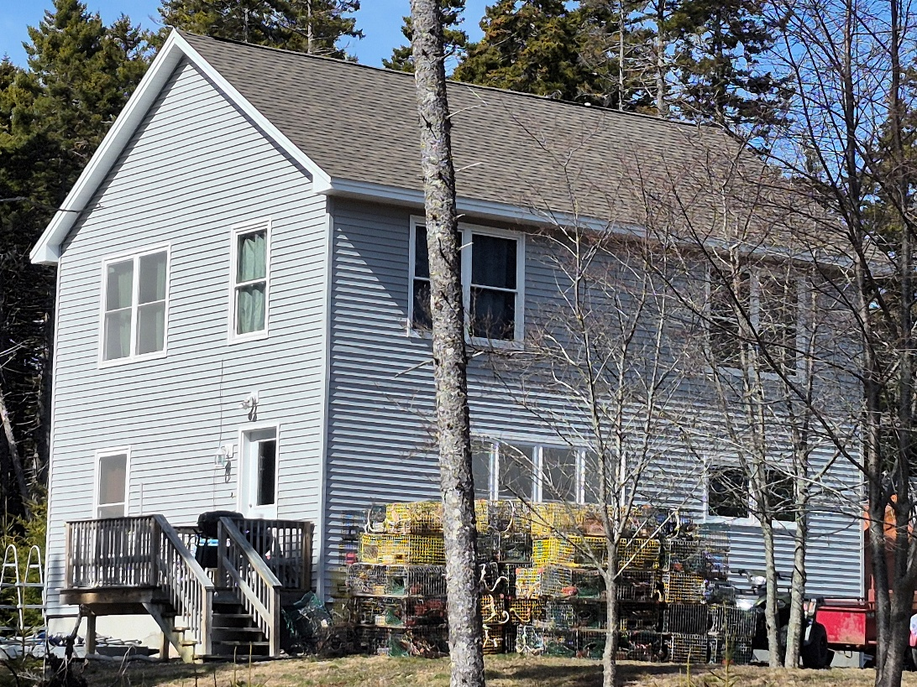
Location: 21 Komusin Lane. Private road in a quiet and secluded wooded area with three other CIRT rental homes, all nicely spaced for privacy. Large yard with room for gardens, play area, BBQ, plenty space for a couple cars. Children in the other three homes as well. Road is plowed.
Description: Built around 2014 the home will be freshly repainted. 3 bedrooms, 1.5 baths, living room, dining area, kitchen, utility room, and basement. Appliances: stove, refrigerator, microwave, dishwasher, washer, dryer. Not furnished. Pets may be allowed. The house is very well insulated and quite energy efficient. Smoking is not allowed in the house.
Monthly Rent: $1,400. Security Deposit: $1,400
Tenant Responsibilities: Propane heat & generator, electricity, Internet, shoveling, mowing.
Availability: House will be available Sept 1 or possibly earlier in August.
Application Deadline June 15, 2026. (CIRT reserves the right to extend the deadline)
Questions: Please contact, Hollie Stanley at hollie.stanley@gmail.com if any questions.

